Campbell River FMLT May 15, 2018
9:00 – 12:00pm
Campbell River Forest District Office
Topics – Key Notes:
Operational Issues Forum Update (Romona Blackwell):
- Fish Permits – looking at blanket permits and streamlining the process
- Pulp Tenures – residuals and securing Fiber
- Integrated investment planning
- RE-charting Process – GBR
- THBL stabilization – WFP has 2 projects on the go
- FREP and small streams and protocols
- OG forest Initiative – Big Tree Policy
- Cumulative Effect
- Professional Reliance
- CP Submissions to be automated
- Lean Log Handling
- Climate Based Seed Transfer
- GBR Implementation Update
- CRIT Update
GBR Update
- Landscape Reserve Design (LRD) - 122 to complete, 11 in progress
- Waiting on Field Manual for Red/Blue – End of June
- Annual Report - G2G forum, March report is currently at G2G
- May 28th next meeting for Guidebook with the Ecologists and Government – possibly exploring a pilot process
- Government considering GIS/Computer analysis For LRD Planning for landscapes not started – this may be available to others as a start
- Changing the definition of OLD to 180yrs due to Climate Change – BEC variants would change
- 5 year review of the GBRO will include FN interests and values
- Training needs: working session with Ron Cotton/John Sunday upcoming
- Purpose of LRD – representation/values – Mid June Meeting
- 2020 will have new targets/TEM update
Re-Charting
- 2 processes – GBR North started last June – some challenges, engaging and changing players – G2G is covering the process – currently a break from the North to allow for a process, allow time for licensees to come up with scope and purpose
  - Reviewing FN process/co-management/sustainability
  - Expect a report out in next 2 months
- GBR South started 2 months ago, data group to have meeting on May 16th - Next meeting for Re-chart will be End of May/Beginning of June
- Licensee driven process, government supports the process and GIS support. Need to end with a consensus
- Principle to use – consider even flow of operations
- Kerry McGourlick looking after the North; Bruce Storry looking after the South
Provincial Timber Objectives

Update on Investment Planning
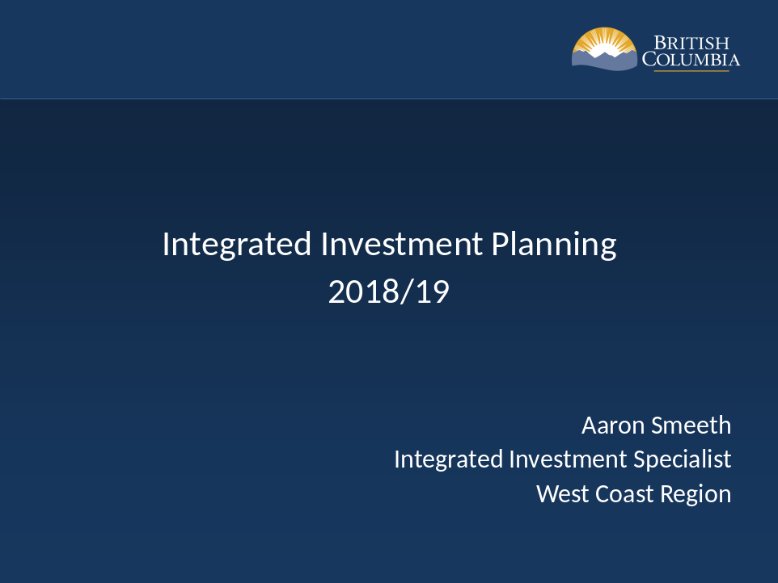

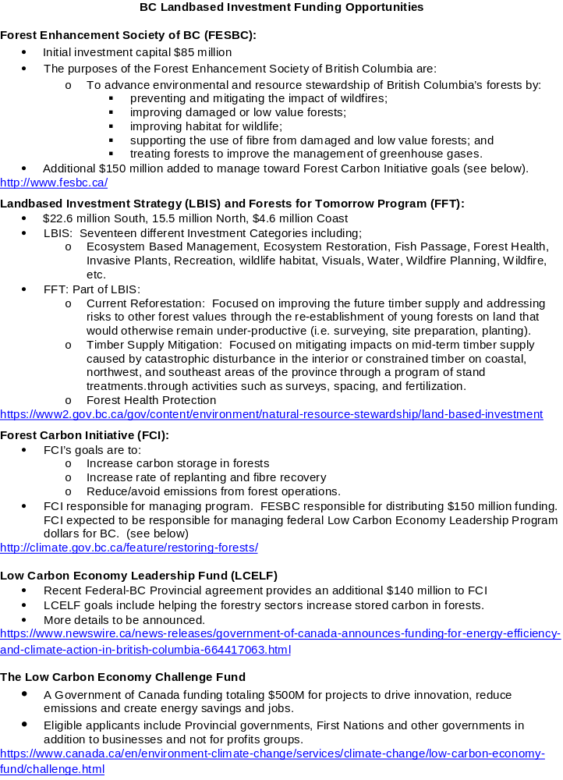
Vancouver Island Old Growth Initiative

- Big Tree Policy accepted by the minister a few weeks ago
Action Items
- Training Needs – General
- Red/Blue Listed Guidebook Training Needs
Next Meeting
- Fall of 2018

